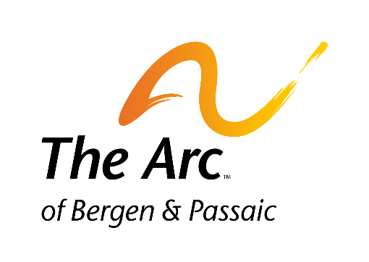MCj02857360000[1]

**Annual**

**Golf and**

**Tennis Classic Fundraiser**

September 29, 2016

Preakness Hills Country Club

1050 Ratzer Road Wayne, NJ 07470

**Silent Auction**

*You can help make the Golf and Tennis Classic a success by donating/soliciting items for the* ***Silent Auction.***

The Silent Auction is an important part of this event. The more items we have for the auction, the more funds that can be raised to support The Arc’s programs and services.

Please consider donating and/or soliciting an item for the Silent Auction.

Here is just a sample of items that we need:

* Limo Rides
* Cruises
* Tours
* Electronics
* iPad/iPhone/i watch
* New Fine Jewelry
* Designer Accessories
* Interesting Gift Items
* Sports Memorabilia
* Golf Items
* Golf Foursomes
* Gift Cards for Stores
* Designer Items
* Hotel Stays
* Vacation Home Stays
* Airplane Tickets
* Gift Baskets with Various Themes
* Tickets to Sporting Events
* Box at Sporting Event
* Tickets to Arts Events (concerts, theater etc.)
* Travel Gift Certificates
* Spa Gift Certificates
* Restaurant Gift Certificates

Donate an item or help by asking your employer, friends and the retail establishments you patronize to provide an item for the silent auction.

I will donate/ have secured a donation of: ___________________________________

______________________________________________ Valued at $ __________________

Contact Name:_____________________________________________________________________________

Address: ___________________________City: ________________________ State: ____ ZIP: ___________

Phone: __________________________ Email: ___________________________________________________

***For more information, please contact Marianne Balazs***

***201-343-0322 x 2225 or*** [***golf@arcbp.com***](mailto:golf@arcbp.com)

***The Arc of Bergen and Passaic Counties 223 Moore Street Hackensack, New Jersey 07601 www.arcbp.com***