Bergen County Sheriff’s Gold Star Id Program

Free photo ID Card for Children with Autism or Developmental Disabilities
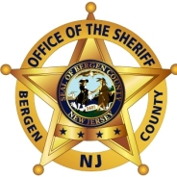 |  | Bergen County Sheriff’s Gold Star Program is a lifesaving initiative for residents over the age of 65 with dementia and for individuals with autism or a developmental disability. The Gold Star ID card provides first responders with vital medical information in the event of an emergency or when an individual is not able to provide the information on their own.
April 22, 2014 6:00 to 8:00
Hasbrouck Heights High School – Media Center

365 Boulevard Hasbrouck Heights NJ 07604

A representative from the Sheriff’s Department will take identification photos and collect information for each individual. All individuals MUST provide a valid Social Security Card to be registered for the Gold Star Program. All residents of Bergen County are welcome to attend and register.

In addition, at 8:00 the Sheriff’s Department will hold an informal session about the Project Lifesaver Program which is a bracelet transmitter used to locate individuals that may elope or wander off. More info can be found at www.bcsd.us

Sponsored by the Hasbrouck Heights Collaborative Parents Committee (CPC).
Questions? Contact Chris Peters 201-393-9504.

