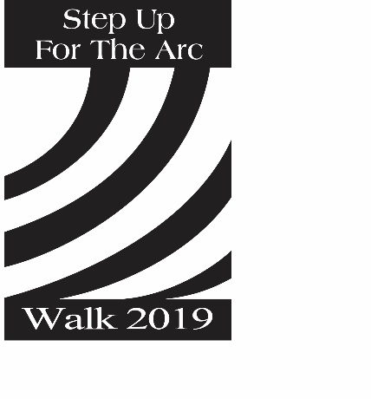
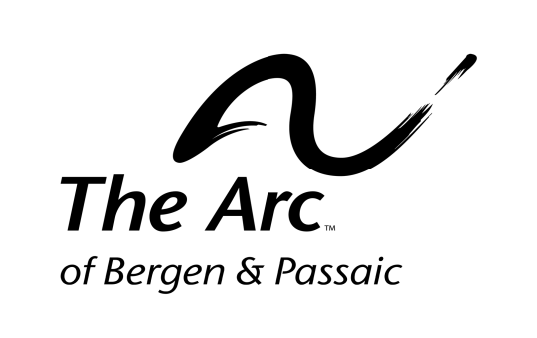
22nd Annual Step Up For The Arc Walk
Sunday, June 9, 2019
Olsen Park, 162. W. Main Street, Bogota NJ

Corporate Walk Teams

We encourage all of our sponsors to participate in our Walk by hosting a corporate walk team. Please indicate:

□ Yes, we_____________________________ will organize a company walk team.
Company Name

Our Team Coordinator will be:
Name | Title | Company | Phone | Email

□ No, we are not interested in forming a walk team this year.

□ I will be walking as an individual or a member of another team.

My Name: __________________________________
Team Name: _________________________________
Team Coordinator’s Name: ______________________
Team Coordinator’s Contact Info: ________________________________
Need Company Walk Team Shirts Created? No Problem.
Contact The Arc’s Elmwood Industries at (201) 703-1220 for more information on how we can design your teams very own shirts.
Thank you for your support!
Please return completed form to:
Development Office, The Arc of Bergen & Passaic Counties
223 Moore Street, Hackensack, NJ 07601
Questions? Please call Shirley Williams at 201-343-0322 ext. 2233

