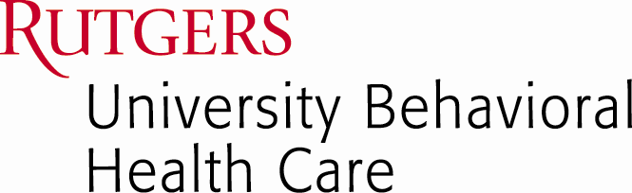
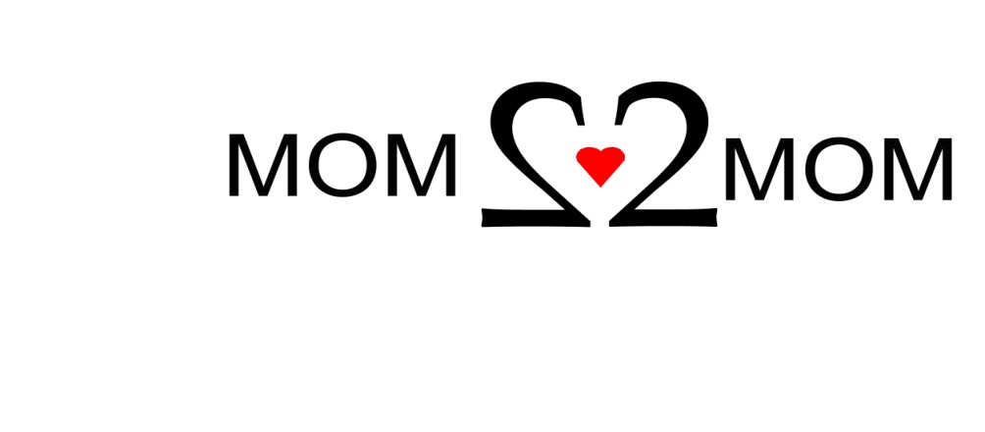
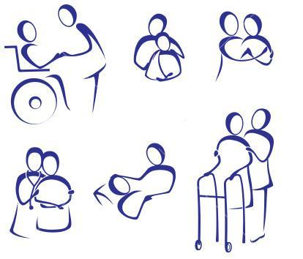
1-877-914-MOM2…MOM
1-877-914-6662
www.mom2mom.us.com

The “MOM 2 MOM” Helpline Program
University of Medicine & Dentistry of New Jersey

You’re caring for your special needs child…Who is caring for you?

At Mom 2 Mom our focus is caring for you….

Mom2Mom
and
The Arc of Bergen & Passaic Counties Inc.

Support Group for Caregivers of
Special Needs Children & Adults

Tuesday, October 14, 2014
7:00 – 8:30 PM

The Arc of Bergen & Passaic Counties Inc.
17-03 A Broadway, Route 4 West
Fair Lawn, NJ
RSVP to Mom2Mom 1-877-914-6662

