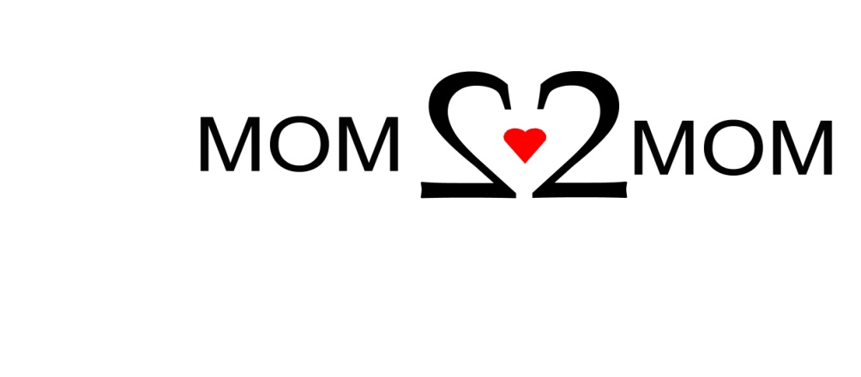

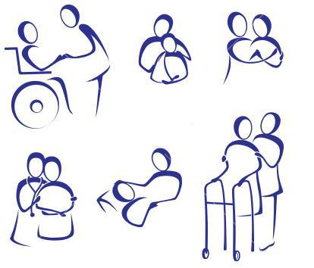

**Mom2Mom**

**and**

**The Arc of Bergen & Passaic Counties Inc.**

**Support Group for ALL Caregivers of**

**Special Needs Children & Adults**

Tuesday, February 17, 2015

7:00 – 8:30 PM

The Arc of Bergen & Passaic Counties Inc.

17-03 A Broadway, Route 4 West

Fair Lawn, NJ

RSVP to Mom2Mom 1-877-914-6662

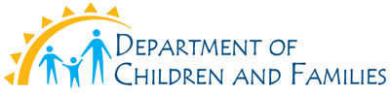

**1-877-914-MOM2…MOM**

**1-877-914-6662**

**www.mom2mom.us.com**