BERGEN COUNTY
25TH ADA ANNIVERSARY CELEBRATION
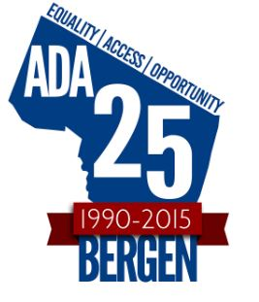
Sponsored by
The Bergen County Division on Disability Services

Please Reserve _________Ticket(s).

(I understand that my Ticket(s) will be held at the door).

Name_______________________________________________________

Street_______________________________________________________

City/ Town __________________________State_______ Zip__________

Phone__________________________________email_________________

Tickets are limited and will be issued on a first come basis!

Please respond by July 15, 2015
Bergen County Division on Disability Services
One Bergen County Plaza 2nd Floor
Hackensack, New Jersey 07601
_____________________
Call regarding special accommodations
at least 2 weeks in advance.
Tammie Adkins @ 201-336-7381 (Voice)
201-336-6505 (TTY)

