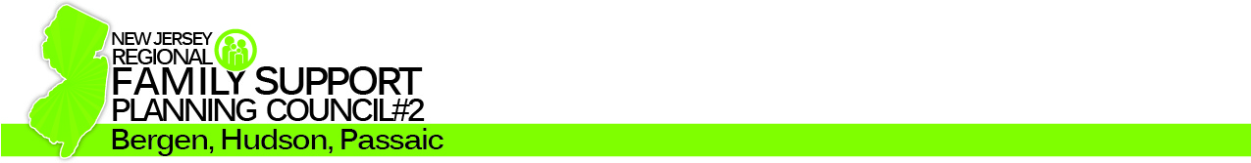

Public Forum and Providers Fair

We invite you and your family to join us...

Where:
Norman Bleshman
School
333 East Ridgewood Ave
Paramus, NJ 07652

Date:
Saturday,
February 22, 2014

Time:
10:00 am – 1:00 pm

RSVP:

RFSPC2@gmail.com

Do you or someone you know have an adult family member with an intellectual or developmental disability (I/DD)?

Do you need services but don’t know how to get them?

Are you aware of the recent changes in New Jersey's
developmental disabilities service delivery system?

If your family member is over 21, do you need more information on DDD's new rule of Mandatory Adult Medicaid Eligibility and the new Supports Program?

Is your child at a transition age (16 – 21) and want to know about self-directed services at age 21 and after?

Please join us and our guest presenter(s) at this free event:

Patricia Brennan, DDD
Director of Self Directed Day Services/Self Determination
And a panel of other parents and support coordinators

Take this opportunity to speak with local service providers that can help you and your family member with I/DD

If you would like to attend, please respond to the email address:
RFSPC2@gmail.com

Regional Family Support Planning Council #2 (Bergen, Hudson, and Passaic Counties) is a group of volunteer family members who host public forums to obtain input to improve family support services provided by the Department of Human Services and the Department of Children and Families.
For additional information call 1-800-216-1199 Option 2.

