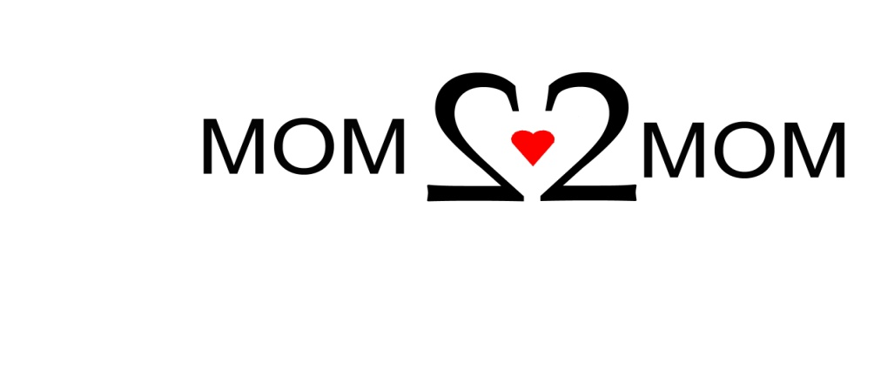

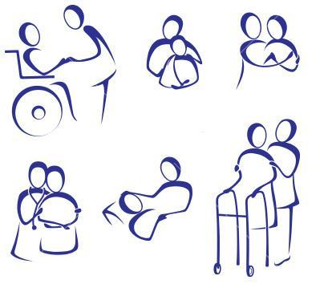
Mom2Mom
and
The Arc of Bergen & Passaic Counties Inc.

Support Group for ALL Caregivers of
Special Needs Children & Adults

Tuesday, November 11, 2014
7:00 – 8:30 PM

Reasons for Gratitude
and
Your Input on Groups Going Forward

The Arc of Bergen & Passaic Counties Inc.
17-03 A Broadway, Route 4 West
Fair Lawn, NJ
RSVP to Mom2Mom 1-877-914-6662

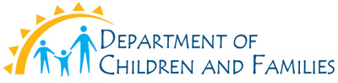
1-877-914-MOM2…MOM
1-877-914-6662
www.mom2mom.us.com

